Question 2

Nginx

First pulled nginx image

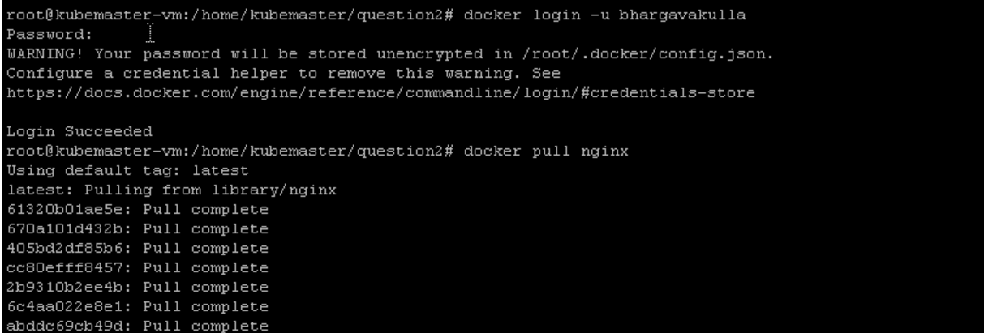

Created deployment.yaml file

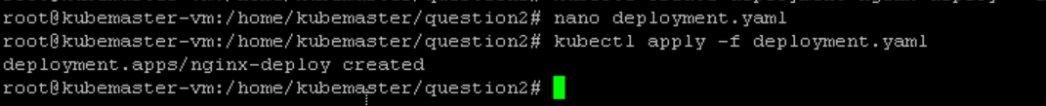

Deployment.yaml

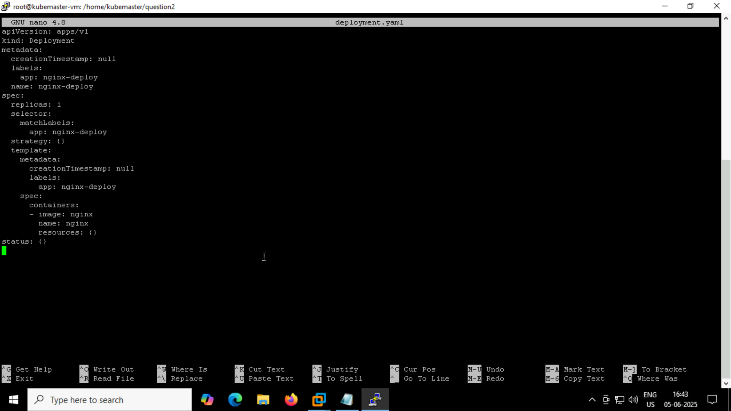

Created service.yaml file

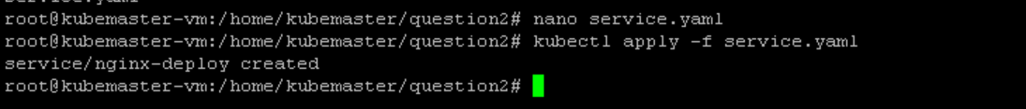

Service.yaml

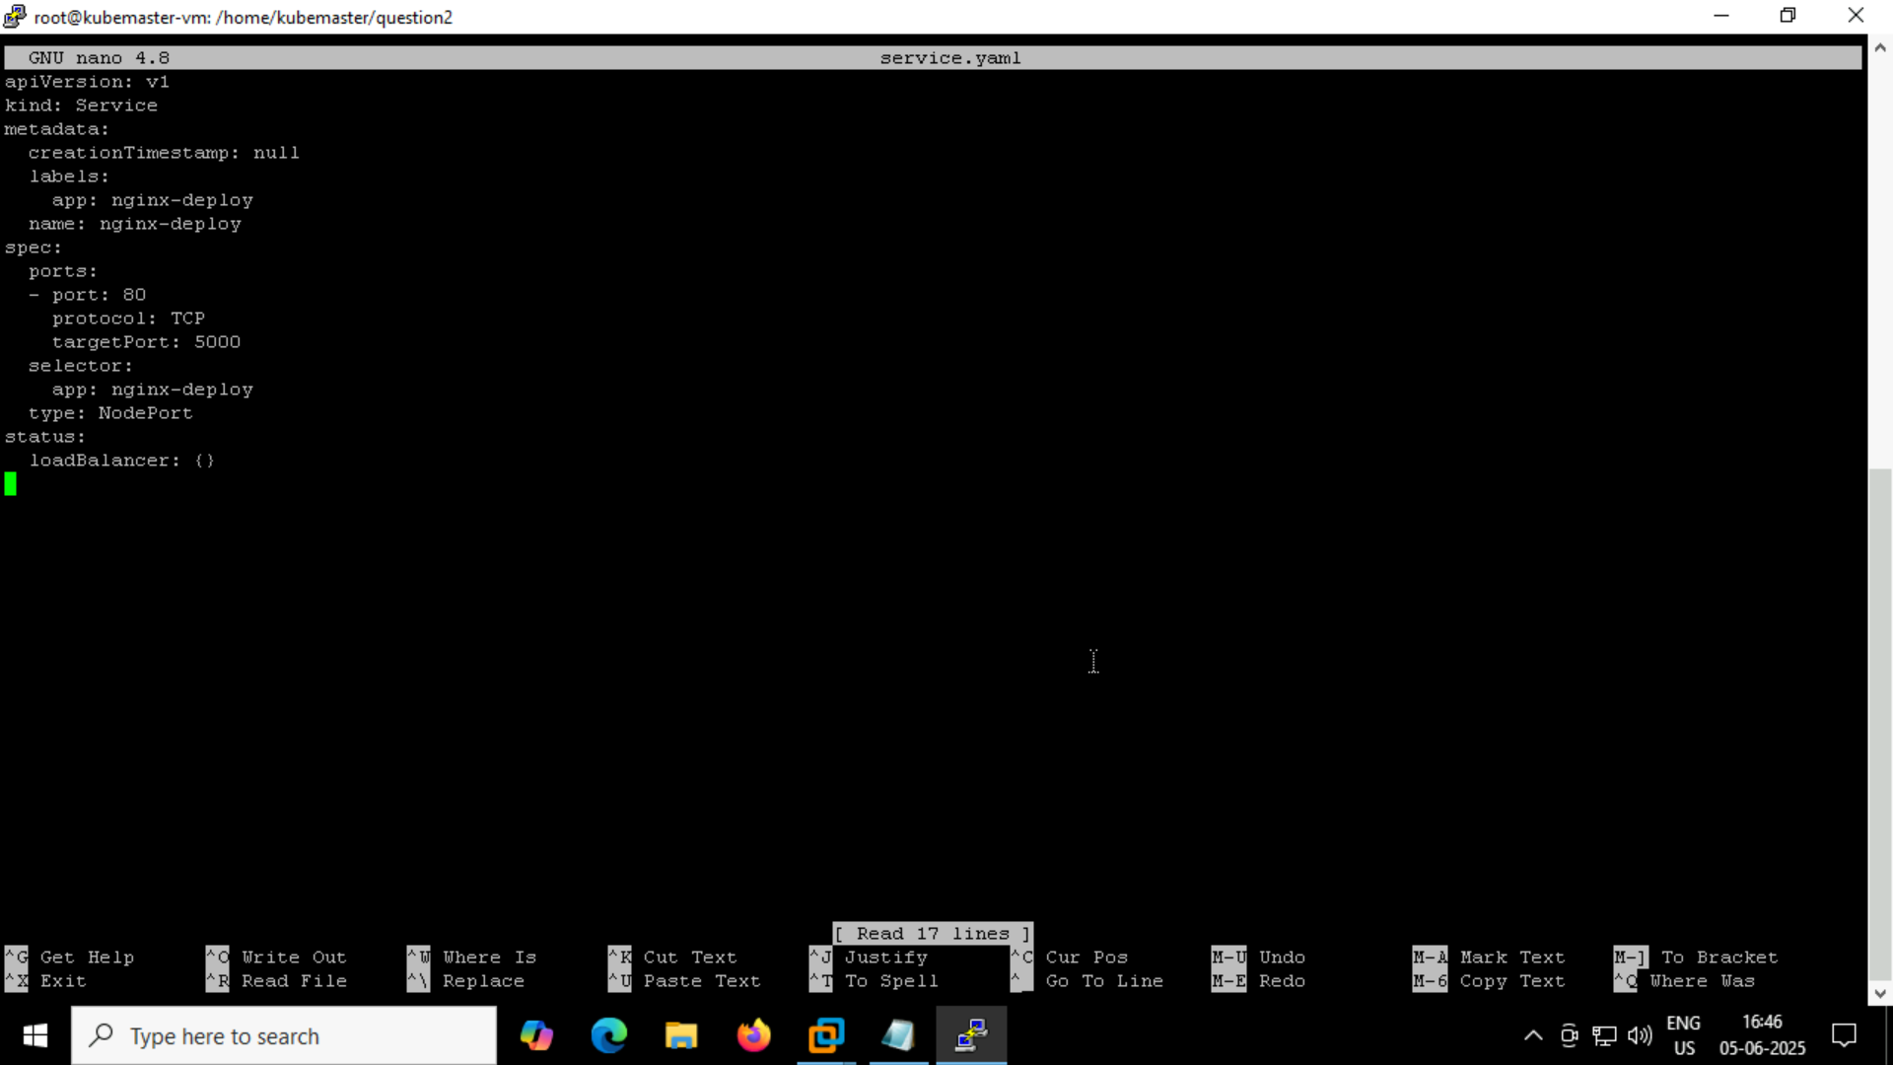

The pod is running successfully and we have given NodePort

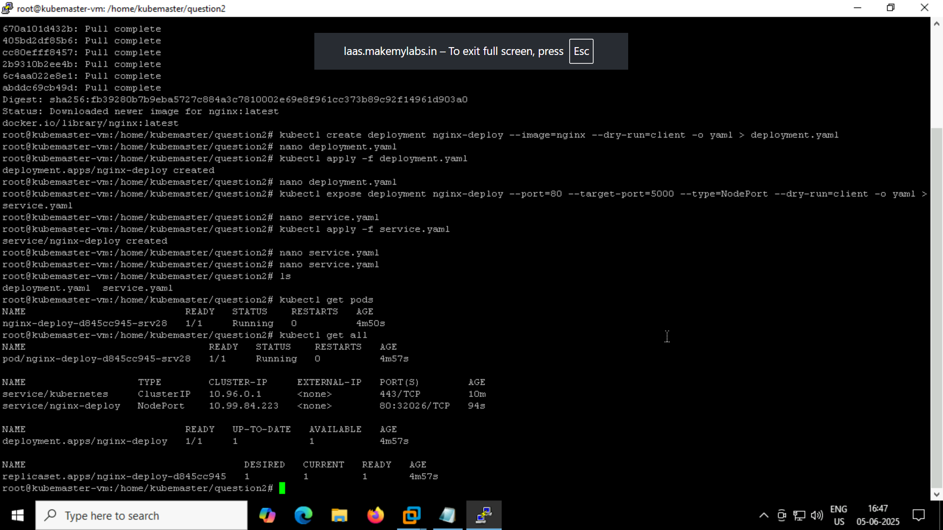

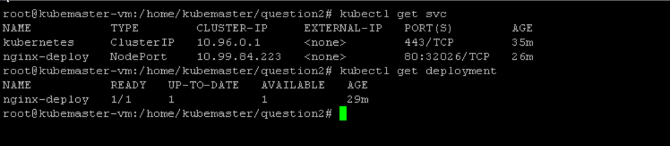

Status of nginx

